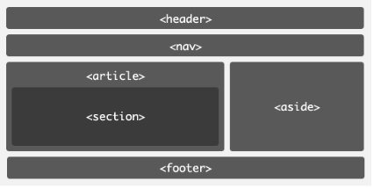
<!DOCTYPE html>
<html ang = "en">
<head>
<meta charset = "utf-8">
<title>HTML5 Demo</title>
<body>
<header><h1></h1><h2></h2></header>
<nav><ul><li></li><li></li></ul></nav>
<section>
<article></article>
<article></article>
</section>
<aside></aside>
<footer></footer>
</body>
</html>

